Phase detector calibration (VCO + splitter / delay line / mixer)
Measured 10 October 2026. Syscomp CGR-201 drives the VCO tuning input Vt (monitored on scope CH1). The VCO's RF output goes through a tee to the SSA3021X spectrum analyzer and to the splitter; the two splitter outputs (one cable about 4.5 in longer) feed the mixer, whose output goes to scope CH2. Vcc 11.5 V. This calibrates the VCO and the phase detector together.

Summary
- VCO: 743.6 MHz at 0 V to 920.0 MHz at 3.50 V (the Syscomp's maximum is 3.52 V). The tuning slope is about 40 MHz/V from 0-1 V, 33 MHz/V from 1-2 V, 75 MHz/V from 2-3 V and 58 MHz/V above 3 V.
- Mixer output: 30.3 to 145.7 mV. It is single-valued in frequency only up to 788.4 MHz (121.3 mV, Vt = 1.20 V), with a mean slope of 2.66 mV/MHz from 750 to 785 MHz. Above that it turns over at 802.2, 834.2, 868.0 and 886.0 MHz.
- Step response: the mixer output follows a step on Vt in 89-140 ns (10-90 %), limited by the Syscomp's own edge of about 145 ns.
- Noise: 84-142 uV rms at the mixer output at full scope bandwidth, equivalent to roughly 40-65 kHz rms of frequency in the usable band. Part of this is the scope's own noise (60-65 uV).
- Drift over 74 minutes: mixer output at a fixed frequency changed by at most 0.37 mV, equivalent to about 140 kHz.
- The Syscomp cannot tune this VCO into the 1.0-1.2 GHz band, which needs roughly 4.8-7.7 V on Vt.

Method note: the DC level must have the waveform switched off
With a waveform selected and amplitude set to zero, the CGR-201 still puts about 100 mV peak-to-peak of that waveform on its output. This made the VCO hop between two frequencies about 3.4 MHz apart during the first two calibration sweeps and the 'bad setup' sweep. Run 3 below was taken with the waveform off and is the one to use. Against it, the earlier frequencies were off by between -1.75 and +0.40 MHz.

1. Static calibration (good setup, clean DC, 176 points in 0.02 V steps)

VCO: output frequency vs input voltage
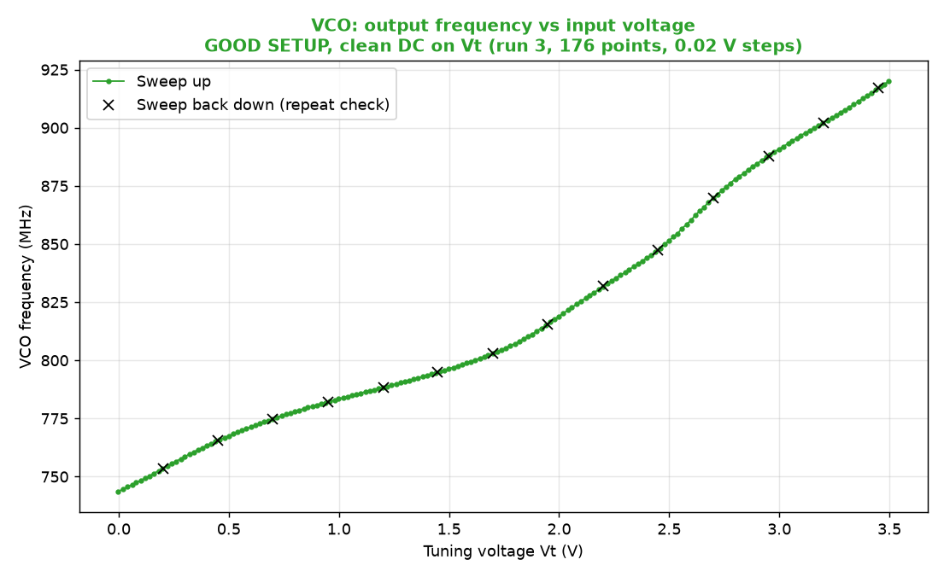
Crosses are 14 points taken on the way back down; they match the upward sweep to within 0.10 MHz.

Splitter / mixer: output voltage vs input frequency
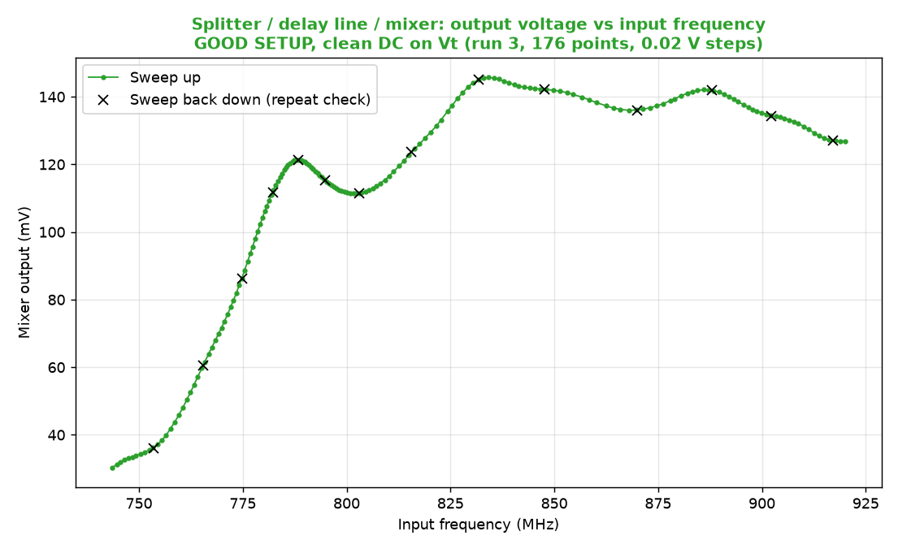
Repeat points match to within 0.22 mV. Frequency can be identified uniquely from the voltage only below 788 MHz.

Whole chain: mixer output vs tuning voltage
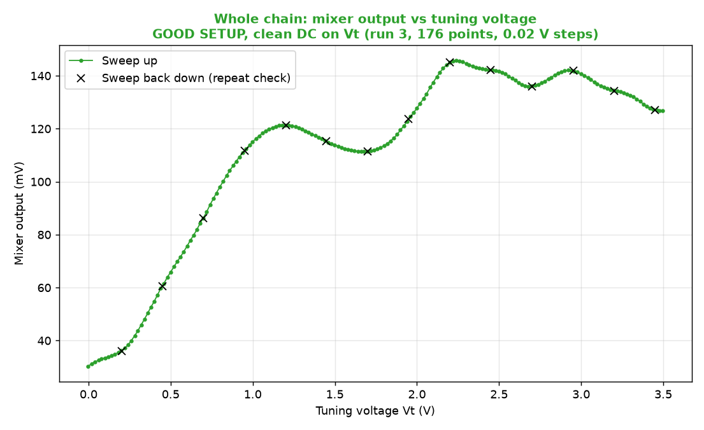
The same data plotted against Vt.

Power reaching the analyzer vs frequency
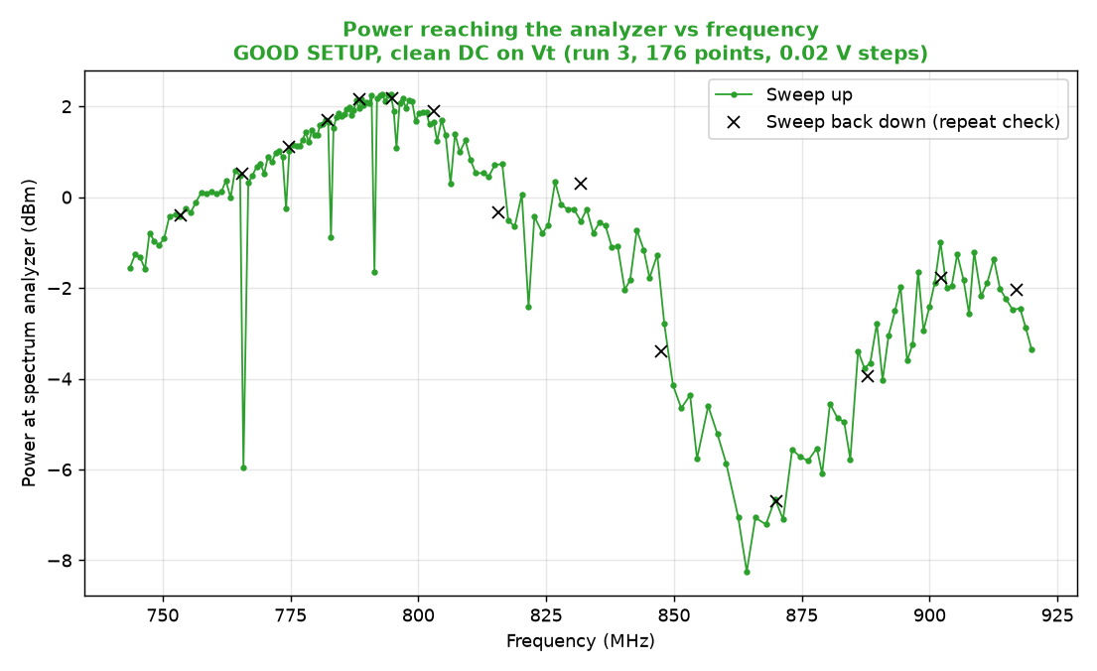
Measured through the tee, so this is not the VCO's true output power.

2. Step response of the whole chain
50 kHz square wave on Vt, about 420 edges averaged per step. Mixer voltage is converted to frequency with the run 3 calibration, valid below 788 MHz.
Edge | Low (V) | High (V) | Mixer start (mV) | Mixer end (mV) | Freq. start (MHz) | Freq. end (MHz) | Mixer 10-90 % (ns) | Freq. 10-90 % (ns) | Drive 10-90 % (ns)
rise | 0.20 | 0.40 | 35.84 | 54.67 | 752.91 | 763.23 | 140 | 128 | 144
fall | 0.20 | 0.40 | 54.66 | 35.84 | 763.22 | 752.92 | 93 | 123 | 144
rise | 0.20 | 0.60 | 36.02 | 75.17 | 753.14 | 771.18 | 124 | 120 | 143
fall | 0.20 | 0.60 | 75.12 | 36.01 | 771.16 | 753.12 | 102 | 133 | 144
rise | 0.20 | 0.80 | 36.22 | 97.66 | 753.39 | 777.89 | 131 | 117 | 145
fall | 0.20 | 0.80 | 97.58 | 36.19 | 777.86 | 753.36 | 108 | 137 | 146
rise | 0.20 | 1.00 | 36.35 | 115.31 | 753.55 | 783.56 | 108 | 111 | 145
fall | 0.20 | 1.00 | 115.23 | 36.32 | 783.52 | 753.51 | 114 | 146 | 146
rise | 0.20 | 1.15 | 36.06 | 121.10 | 753.18 | 787.21 | 89 | 112 | 143
fall | 0.20 | 1.15 | 121.06 | 35.99 | 787.16 | 753.10 | 116 | 151 | 149
rise | 0.30 | 0.40 | 44.15 | 54.85 | 758.78 | 763.29 | 126 | 125 | 145
fall | 0.30 | 0.40 | 54.84 | 44.15 | 763.29 | 758.78 | 122 | 131 | 145
rise | 0.50 | 0.60 | 65.99 | 75.41 | 767.60 | 771.27 | 126 | 124 | 142
fall | 0.50 | 0.60 | 75.39 | 65.98 | 771.26 | 767.60 | 125 | 126 | 143
rise | 0.70 | 0.80 | 87.11 | 97.99 | 775.00 | 777.98 | 122 | 122 | 141
fall | 0.70 | 0.80 | 97.98 | 87.10 | 777.97 | 774.99 | 127 | 128 | 142
rise | 0.90 | 1.00 | 108.05 | 114.90 | 780.92 | 783.39 | 116 | 125 | 140
fall | 0.90 | 1.00 | 114.90 | 108.04 | 783.39 | 780.91 | 128 | 124 | 140
rise | 1.00 | 1.10 | 115.37 | 119.78 | 783.58 | 785.89 | 97 | 107 | 139
fall | 1.00 | 1.10 | 119.78 | 115.36 | 785.89 | 783.58 | 124 | 119 | 141

Rising edges
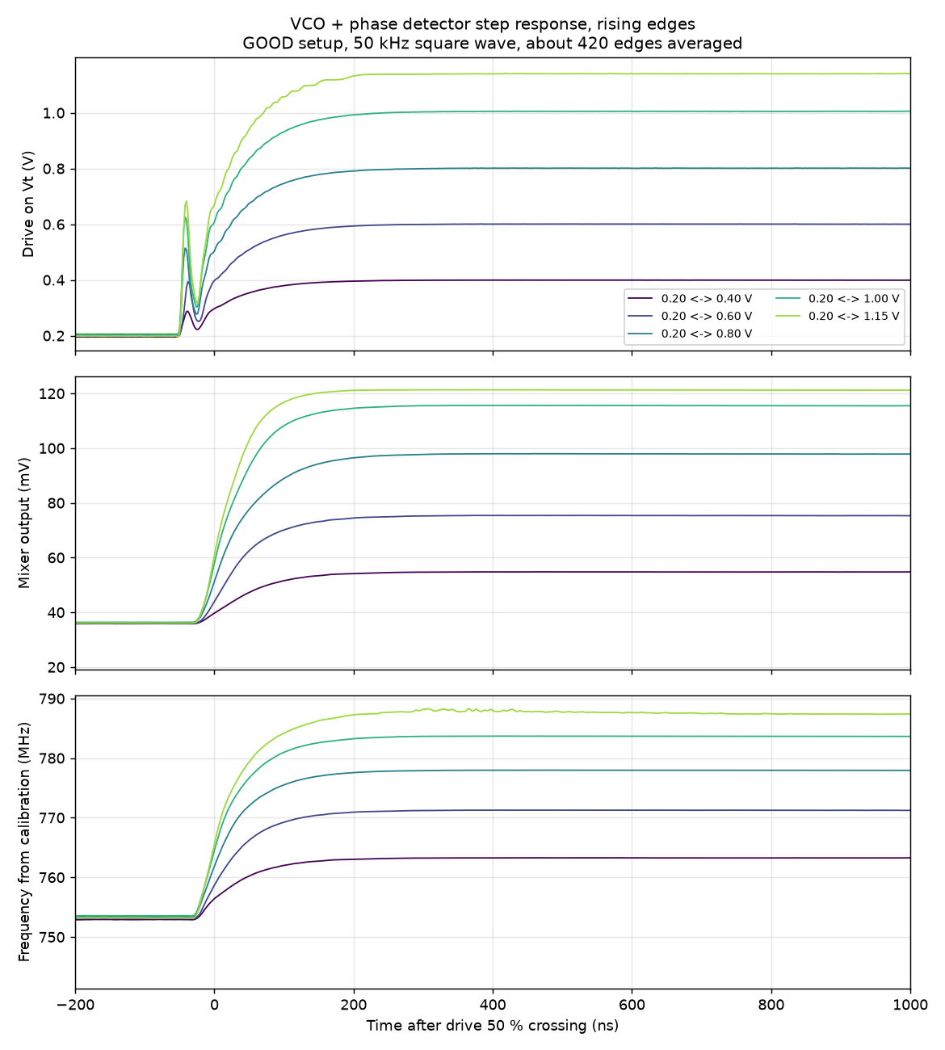
Drive voltage, mixer output and inferred frequency, steps from 0.20 V.

Falling edges
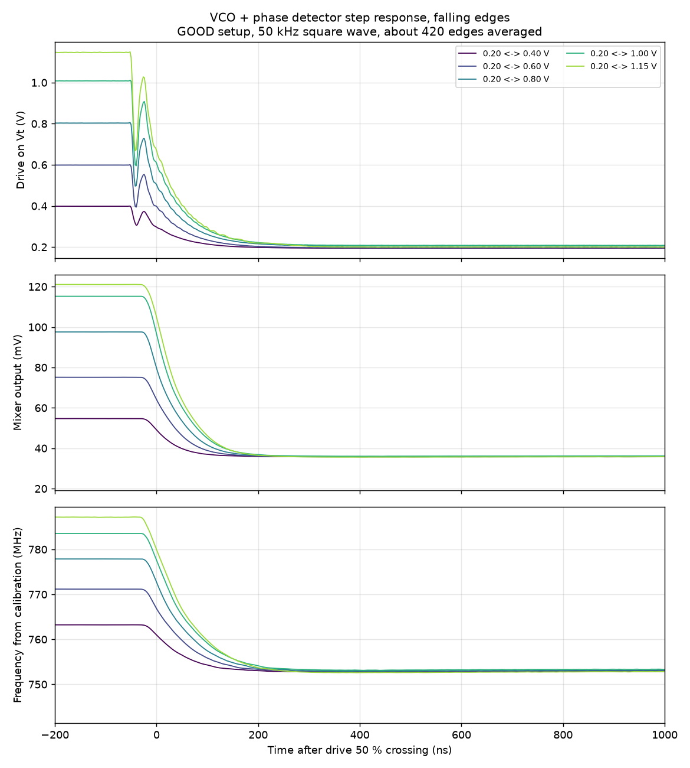
The same steps, falling.

Transition time vs input voltage
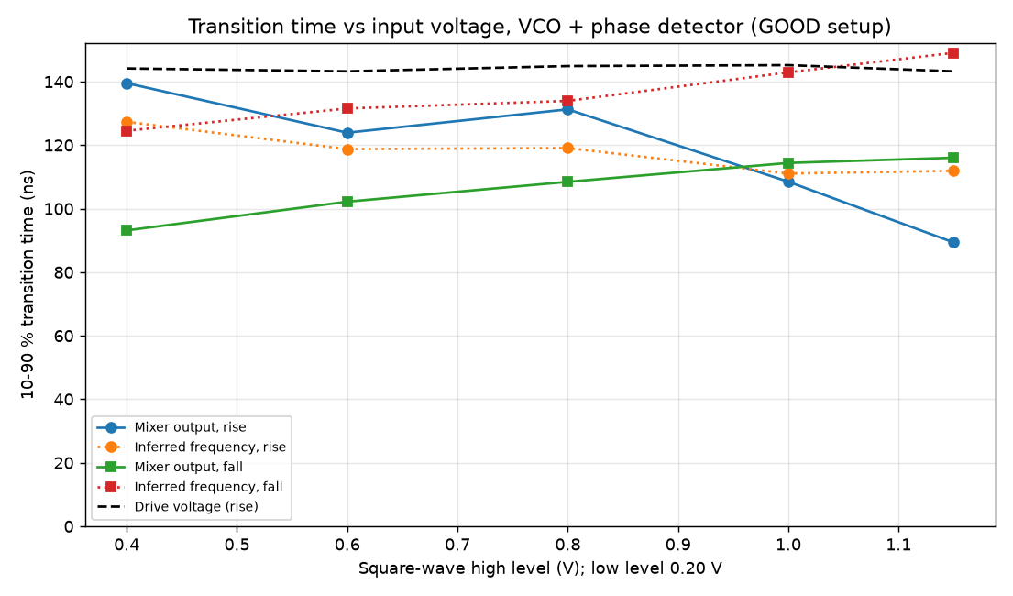
10-90 % transition times of the mixer output, the inferred frequency and the drive.

3. Noise and resolution (clean DC)
Vt (V) | Freq. (MHz) | Slope (mV/MHz) | Mixer rms, full BW (uV) | Scope floor (uV) | Freq. noise, full BW (kHz) | Freq. noise, 1 MHz BW (kHz) | Freq. noise, 100 kHz BW (kHz)
0.10 | 748.3 | 0.45 | 84.3 | 62.5 | 186.2 | 114.8 | 74.8
0.20 | 753.5 | 0.85 | 90.8 | 62.3 | 106.5 | 70.9 | 37.4
0.30 | 758.5 | 1.98 | 128.0 | 59.9 | 64.8 | 51.0 | 23.2
0.40 | 763.3 | 2.67 | 137.8 | 62.4 | 51.7 | 41.7 | 16.6
0.50 | 767.5 | 2.46 | 126.3 | 60.5 | 51.3 | 40.4 | 18.0
0.60 | 771.4 | 2.90 | 129.1 | 62.1 | 44.6 | 35.4 | 17.7
0.70 | 774.8 | 3.36 | 141.7 | 61.2 | 42.2 | 34.6 | 15.8
0.80 | 778.0 | 3.64 | 136.5 | 62.5 | 37.5 | 30.5 | 14.7
0.90 | 780.8 | 3.17 | 116.7 | 61.1 | 36.8 | 28.1 | 12.6
1.00 | 783.4 | 2.32 | 100.9 | 65.1 | 43.5 | 30.9 | 14.0
1.10 | 785.9 | 1.27 | 83.7 | 62.7 | 65.6 | 39.6 | 20.7
Frequency noise is the mixer's voltage noise divided by the local slope. The scope floor was recorded on an unconnected channel with the same settings; the figures are not floor-subtracted, so they are upper limits.

4. Drift (18 repeated sweeps over 74 minutes)

Drift vs time
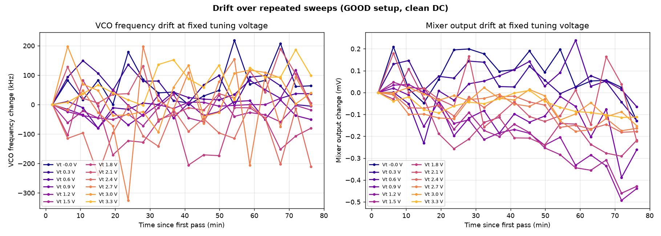
Change in VCO frequency and mixer output at fixed tuning voltages. The voltage setting repeats to about 1.7 mV, which accounts for part of the frequency scatter.

5. Good vs bad setup (for reference only)
The 'bad' setup had an extra tee with an open, unterminated port; the 'good' setup replaced it with a male-male adaptor. Both plots below use data taken before the waveform-off fix, so their frequencies are off by up to about 1.7 MHz, and the power panel of the bad-setup plot is unreliable (the analyzer was being read before its sweep finished). The bad sweep was stopped after 15 points (0 to 0.7 V).

Comparison
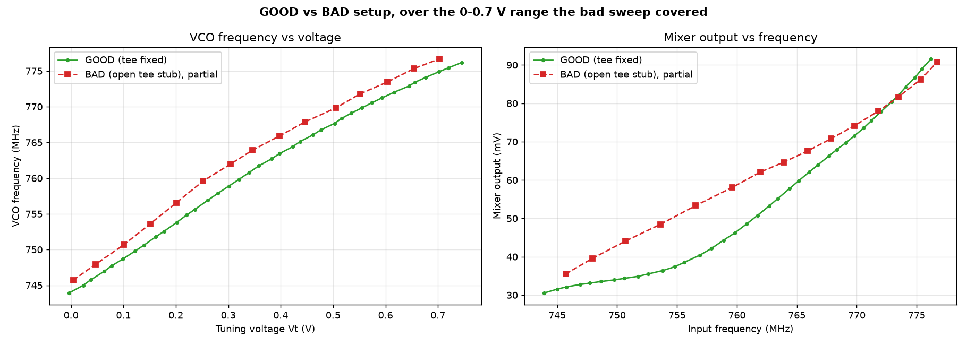
Good (run 2) against bad, over the range the bad sweep covered.

Bad setup, partial sweep
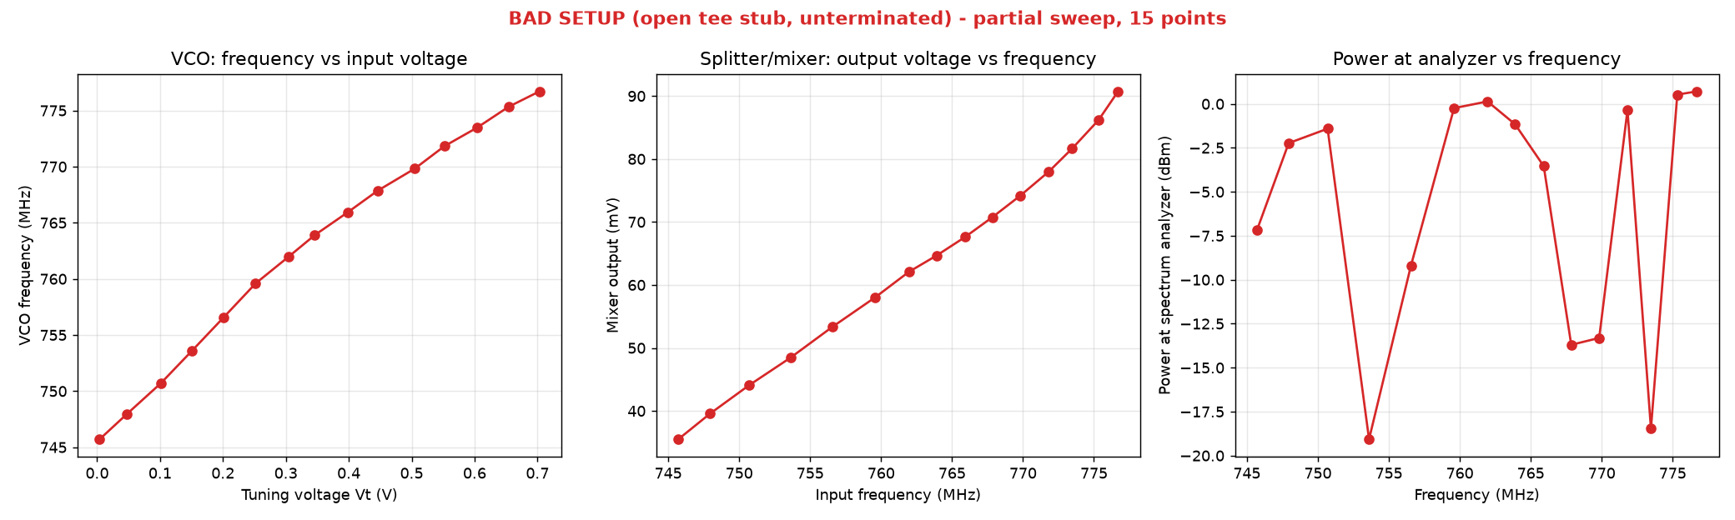
The 15 points recorded with the open tee stub.
Data and scripts: clinic/phase_detector_calibration/. Main data file: phase_detector_calibration_run3_cleanDC_0p02V_steps.csv.

